Web Accessibility Conformance Guide for Content Managers
Last updated: February 27, 2019

Document purpose
Content manager fixes
Replace or provide accessible PDFs where necessary
Locating PDFs
Remediating PDFs
If a non-conformant PDF is no longer relevant or crucial.
If a non-conformant PDF is still relevant or crucial.
Manually check other documents for accessibility
Embedded videos: Transcripts, Captions, and Audio Descriptions
Media formats detected
Video-only media (non-live)
Audio-only media (non-live)
Non-live Multimedia (audio + video)
Live Multimedia functionality (audio + video)
Live video-only, Live audio-only
Media Alternatives
Audio Description
Transcript
Captions
Images: Alternative Text
All images need an alt text field (even if it is blank/empty).
Appropriate Alt Text for decorative images.
Appropriate Alt Text for Images serving as links, buttons, or controls
Image has text next to it, describing where the link directs to. .
Image is a link, with no text describing where the link directs to.
Appropriate Alt Text for Informative Images (purpose is not decorative)
Informative Images
Logos
Charts and Graphs
Informative Icons
Images of text
Improper use of Alternative Text
Broken links need to be resolved.
Identical link text should not be used to go to different locations.
Generic link text should be avoided, but the purpose of the link text must be determined by the surrounding content.
Tables are used for layout purposes in an inaccessible manner or they use inline styles.
Content needs some proofreading.
Misspellings are present on the site.
Headings are not used correctly.
Heading level assignments do not follow proper hierarchy.
Paragraphs are used in place of headings (or vice versa).
Headings should be structured in sequence.
Headings are left blank.
Other areas for consideration
Fixes implemented by Custom Development

Document purpose
The purpose of this document is to provide an easy to understand list of items to update or fix in order to conform to Cornell University’s standards for web accessibility (WCAG 2.0 Level AA).

Content manager fixes

Replace or provide accessible PDFs where necessary

Locating PDFs
Siteimprove will locate and index PDFs on your site. The list of PDFs can be found by opening the menu then navigating to Quality Assurance > Inventory > Documents > PDFs

Siteimprove is also able to identify PDFs with certain accessibility errors. This can be useful as a starting point, but do not rely solely on it, since not all PDF accessibility errors are detected by Siteimprove. The list of PDFs with accessibility errors detected by Siteimprove is located at Accessibility > PDFs.

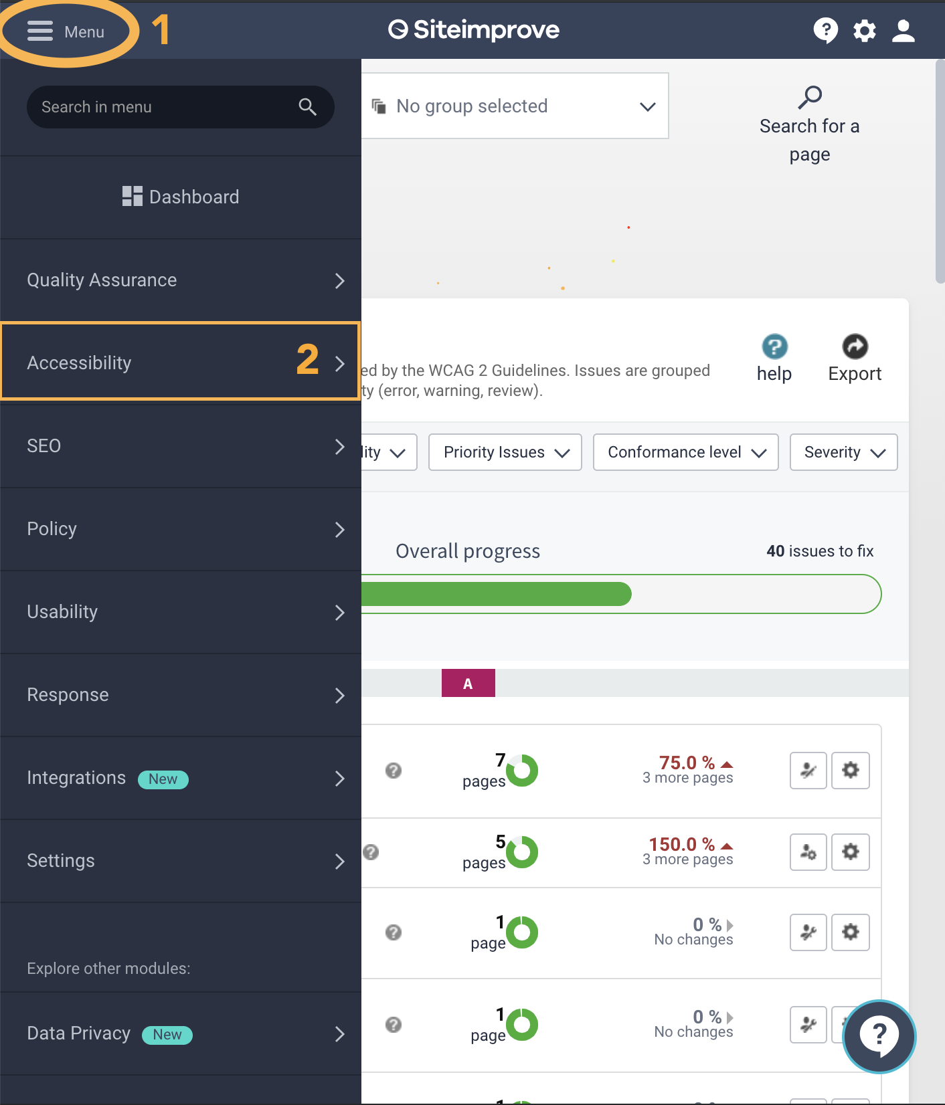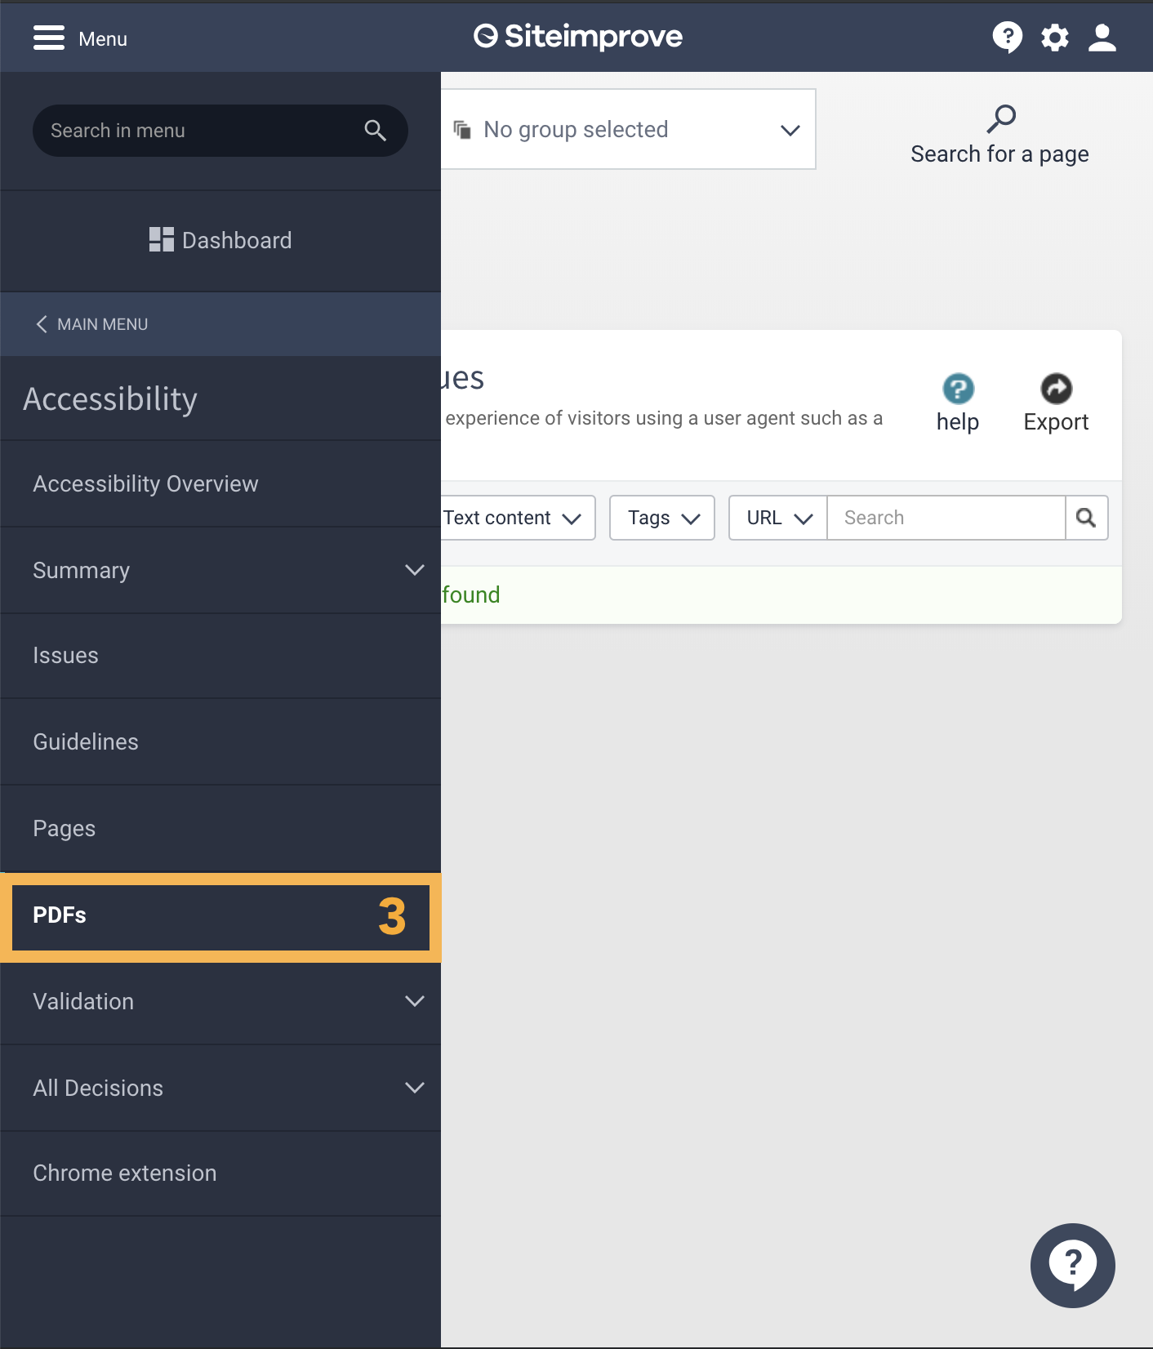

SiteImprove will scan PDFs up to 15MB and any detected accessibility errors will be reported. Remember that you still need to manually evaluate the PDFs for any missed accessibility errors.

Any PDFs above 15MB will not be automatically scanned by Siteimprove at all and you will have to rely on other tools (such as Acrobat) to evaluate Accessibility.

Remediating PDFs

If a non-conformant PDF is no longer relevant or crucial.
Remove the PDF from the site altogether and remove any links/content that referenced it.

If a non-conformant PDF is still relevant or crucial.
First attempt to convert the PDF to a webpage, carrying over all content. This is a faster and easier method of remediation. This includes converting PDF forms to webforms. If that is not possible for any reason, then the PDF itself must be remediated.

To remediate PDFs themselves, start by running Adobe Acrobat’s built in accessibility report on your PDF. This will identify most accessibility issues that must be fixed. Right click on any error and it will give you an explanation of the issue.

Where possible, return to the original source file to address as many accessibility issues as possible (Headings, Lists, Links, Alternative Text, Tables, Document Title, Language Settings). This is typically faster and easier than remediating the PDF.

Once complete, rerun the accessibility checker on the new PDF and address any remaining issues in Acrobat (Reflow Order, Adding and Tagging Form Fields). You can . Any

You must manually check for more issues than the automated report will provide. Certain issues include
- Ensuring that you avoid the use of all caps.
- Ensuring that you do not use underlines except for links.
- Justified text should be avoided
- Link text should be understood OUT OF CONTEXT. (Do not use “More” or “Link”)
- Color contrast is sufficient
- Keyboard navigation is logical
- Screen reader can read the document correctly

For more detailed instructions on remediating PDFs visit
https://it.cornell.edu/accessibility/create-accessible-pdfs

Manually check other documents for accessibility
Any Word, Excel, or PowerPoint documents must be manually inspected for accessibility. You can use the built-in accessibility checkers provided in Microsoft Word, Microsoft Excel, and Microsoft PowerPoint as a starting point. The checker can be found under Review > Check Accessibility. Be sure your documents at a minimum pass the built in inspector.

Siteimprove will list all documents under Quality Assurance > Inventory > Documents.

Embedded videos: Transcripts, Captions, and Audio Descriptions
Web Accessibility standards require different accommodations for time-based media (video and audio) depending on the properties of it. You must manually ensure that each form of media is compliant with web accessibility standards.

Listed first are the different forms of media that are most commonly found around the

Media formats

Video-only media (non-live)
Video-only media is any non-decorative only video content that has no audio or no audio that is relevant to the content. You must provide the following media alternative:

- Audio Description

Audio-only media (non-live)
Audio only media includes podcasts, conference recordings, and pre-recorded radio broadcasts. This includes if you were to host audio-only content on a video streaming service like YouTube (where any visual content is not relevant to the audio content; i.e. you just display a Cornell logo for the entire video). They must be accompanied by the following media alternative:

- Transcript

Non-live Multimedia (audio + video)
If you have a video that contains audio, you must provide the following media alternatives:

- Captions
- Audio Description (read below)
- Transcript if Audio Description is not required

Live Multimedia functionality (audio + video)
If you ever provide live multimedia (such as a stream), you must provide the following media alternative. Do note that if you then make an on-demand version of this live multimedia, you must then obey the rules for non-live Multimedia.

- Captions

Live video-only, Live audio-only
If you are streaming live video (such as a livestream of the Cornell Campus without audio), or if you are streaming live audio (such as a radio broadcast), there are no additional media alternatives that you are obligated to provide.

Media Alternatives

Audio Description
Video-only and Non-live Multimedia
If a video in question requires Audio Descriptions (if visual information in the video is important to understanding the message of the video), they must be provided as either an alternative audio track or it can be a different, modified version of the original video. If you create a different video specifically for the purposes of audio descriptions, it should at least be linked next to the regular version of the video.

Transcript
Audio-only (and non-live multimedia as an option)
You must provide a text-format transcript. It can either be below the video or externally linked near the video.

Transcripts MUST abide by the following guidelines:
- All scripted content must be transcribed verbatim.
- Important background sounds must be conveyed (ideally in brackets or parentheses)
- The identity of the speaker must be included in transcripts.

Captions
All multimedia (live and non-live)
Captions must be included on all multimedia.

Captions MUST abide by the following guidelines:
- All scripted content must be captioned verbatim.
- Important background sounds must be conveyed (ideally in brackets or parentheses)
- Any speech that is spoken off-screen must be captioned (italics is best practice for this scenario)
- The identity of the speaker must be included in captions.
- Captions must be timed appropriately with the audio.

Images: Alternative Text
Certain images on the site need to have alternative (alt) text applied to them in order to describe the purpose of the image. The alt text that must be provided is different depending on the context of the image. In ALL scenarios, do NOT put “Image of” or any variation thereof in the alternative text field. For people who use screen readers, the reader will announce “Image of” followed by the description which will result in repetition.

All images need an alt attribute (even if it is blank/empty).
Siteimprove and WAVE will flag these errors. If they exist, consult with your developers and designers about adding the alt attribute.

Some Drupal sites may be configured where an alt attribute (even an empty one) will only be added when a space or double quotes is added to the alt text field of the image, thus the responsibility of adding the alt attribute will shift to content editors.

Appropriate Alt Text for decorative images.
Decorative images are any image that doesn’t add any meaningful content, or are used for layout/non-informative purposes. Furthermore, these images are not links or part of a link. Any decorative image MUST be given EMPTY alt text (<img alt=””>).

In most Content Management Systems, this is achieved by simply leaving the alternative text field blank. However, you may need to add a space or double quotes (“”) to the alternative text field on some CMS platforms to achieve this.

Appropriate Alt Text for Images serving as links, buttons, or controls

Image has text next to it, describing where the link directs to.
In this instance, the link should encompass the image and the link text, and the image should have null alt text.

Image is a link, with no text describing where the link directs to.
In this scenario, the alternative text should be the title of the page/site the link directs to.

Appropriate Alt Text for Informative Images (purpose is not decorative)

Informative Images
Images that serve an informative purpose and NOT just for decoration must have concise meaningful alternative text that can adequately describe the purpose, meaning, and intent of the image. Consider the context of the image when writing the alternative text.

Logos
Alternative text for a logo should be the name of the brand or company it represents (such as the Cornell University logo/seal).

Charts and Graphs
Charts and graphs should describe the content and purpose of the chart/graph. The alternative text must still be concise. If you cannot adequately describe the chart or graph in one or two concise sentences, the alternative text should be provided in its full context somewhere else. If all the content of the graph is described in text on the same page, then the chart or graph should have null alt text.

Informative Icons
Icons should have alternative text that describes what information you are trying to convey by having the icon there. For instance, if you put an icon designed to indicate that a link leads to a PDF file, the alternative text should be simply “PDF File” (since the title of the document should be in plain text next to the icon anyway).

Images of text
With the exception of logos, any images that consist solely of text must be replaced with regular text in its place. It can then be styled using CSS.

Improper use of Alternative Text
Double check the alternative text of your images to determine if they are descriptive enough. One method of finding issues would be using your site analytics to find the most visited pages and use the Chrome Web Developer extension to show alt attributes (Images > Display Alt Attributes). The WAVE extension is also capable of displaying alternative text when you hover over the alt icon. You want to look for images that have alt text already, but the alt text does not meet the guidelines specified above.

Ensure that there are no broken links.
Broken links need to be resolved so that they are either removed or replaced with the correct webpage you intend to direct the user to. Siteimprove will list out all broken links by navigating to Quality Assurance > Links > Broken Links.

Identical link text can not be used to go to different locations.
Links to different locations found on the same page can not use the same link text unless there is enough context to differentiate between them.

Examples of Context
The following examples of context are adequate for accessibility compliance if the link text on its own is not enough to
- The link text is enclosed in the same HTML paragraph (<p>) as the rest of the context.
- The link text is described by two table headings.
- The link text is described by a parent list item (such as in a navigation)
- The link text is given additional context using ARIA.

Generic link text should be avoided, but the purpose of the link text must be determined by the surrounding content.
Minimize the use of “Click here” or “More..” as links. Instead, the context is a better option to have as the link text. However, it is mandatory that the purpose of the link text can be determined by the surrounding text or context.

Tables

Layout Tables
Layout tables should not be used in general as a best practice. If you must (such as in an email), tables that are used for layout purposes must exclusively use <table>, <tr>, <td>, and <tbody> tags, and none of the tags may have the summary, caption, colspan, rowspan, headers, or scope attribute applied to them.

Tables used for tabular data
All tables used for tabular data require table headings (<th>) on at least one row or column.

Furthermore, tables should not have any inline styles applied to them (such as declaring a width/height in anything but the CSS). If your content management system allows you to input table widths/heights/cellpadding etc., leave those fields blank.

Proofreading your content.
Misspelled words can disrupt all users from understanding the content of your site. Siteimprove is able to point out misspellings and potential misspellings in your site content for you. From the dashboard of Siteimprove, navigate to Quality Assurance > Spelling > Misspellings or Quality Assurance > Spelling > Potential Misspellings.

As for reading level, it is recommended to keep the Flesch-Kinkaid level below “Lower Secondary Education” as a guideline. This is not mandatory, but in general try to avoid using too many obscure words.

Headings

Heading level assignments must follow proper hierarchy.
When choosing heading levels, they must represent the hierarchy of the content. If a heading is a child of a parent heading, the child heading must be a lower level heading than the parent.

All child headings should be ordered in sequence (ergo, child headings of a level 2 should be level 3), all sibling headings must have identical heading levels.

Child headings can come before the parent if it makes sense for the structure of the site so long as they are labelled in sequence. (You can have a heading level 2 for a navigation for example appear before the heading level 1 which represents the heading of the page content).

Paragraphs cannot be used in place of headings (or vice versa).
Paragraph text is not to be used as headings, same goes for headings as paragraphs. This causes significant confusion for screen readers. Ensure that you are not using headings to have differently styled text in your content management system.

Headings must not be empty.
Any heading (<h1> through <h6>) that is present on the page must have content. They are not to be used for strictly presentational purposes.

